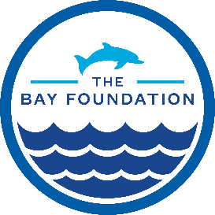

Dear guests,

The Bay Foundation’s 4th annual Coastal Connections is this Thursday, October 11thfrom 5:30 to 8:30.

Pacific Park wristbands and game cards will be available for pick up starting at 4:00.
At 5:30, the venue will open for happy hour, appetizers, and a silent auction.
The buffet dinner will start at 6:15 and the formal program at 6:30.

Biking, Metro, or Big Blue Bus to CC4

We encourage everyone to bike, bus, train, (the expo line ends a block from the pier) to the Santa Monica Pier. The venue is located around the corner from the Ferris Wheel and staff will be on the pier to direct guests, look for The Bay Foundation logo.

Driving to CC4

Parking is available at Lot 1 North, located immediately north of the Pier at 1550 Pacific Coast Highway. Parking fee is $14. After parking, take the stairs behind Bubba Gump Shrimp up to the pier, turn right and the venue will be on the left just after Wetzel’s Pretzels. Staff will be on the pier to direct guests, look for The Bay Foundation logo.

Attire

The event will be outside at the end of the pier and can get chilly when the sun sets. We suggest bringing layers and wearing appropriate footwear for walking on the pier.

Thank you for supporting The Bay Foundation and we look forward to seeing you at Coastal Connections!

